**LPG Gas Sensor Interfacing with LPC2148**

**TEAM MEMBERS:**

**ATLA SURAJ REDDY – AM.EN.U4CSE20012**

1. **S. K. VISWAS – AM.EN.U4CSE20013**

**N. SAI SANDEEP - AM.EN.U4CSE20049**

**PADALA LAXMI PRANEETH – AM.EN.U4CSE20052**

**CGS PRANAV ADVAITH – AM.EN.U4CSE20056**

**Abstract:**

There are many gases available in the environment. Like that there are many sensors available to detect particular gas. In this tutorial, we are going to detect LPG gas. So, we need to use the MQ-2 sensor. There are many MQ sensors to detect many gases such as Helium, Hydrogen, etc. We have taken up LPG gas detection because the use case of LPG throughout the world is really high and the scope for the usage of other gases is limited. So, this module helps to detect if any LPG gas leakage takes place which eventually helps in preventing fire accidents caused due to LPG gas leakage. In recent years due to explosion of LPG number of deaths has been increased. In this paper, a method is proposed to implement a security system for detecting leakage of gas. This system detects and monitors the leakage of Liquid petroleum gas (LPG) using gas sensors and send signal to the microcontroller then microcontroller alerts the person about the gas leakage.

**Introduction:**

Liquid petroleum gas is used as industrial fuel and for domestic purpose. The main constituents of LPG are propane and butane which is highly flammable chemical. It is odourless and has characteristic of smokeless burning in the air. LPG is also used as fuel in vehicles due to increasing prices of petrol and diesel. Leakage of this gas is a serious problem. The gases being heavier than air do not disperse easily and it may lead to suffocation when inhaled. The gas leakage in the air cause explosion. In this case, some high security system becomes necessary and essential. Gas leakage detection is the process of identifying potentially hazardous gas leaks by sensors. In order to monitor its presence sensing elements are deployed in its premises to detect the leakage and to avoid the accidents. A number of papers have been published on gas leakage detection and prevention techniques.

**Selecting between Sensor type and a module type**

When it comes to measuring or detecting a particular Gas the **MQ series Gas sensors** are the most commonly used ones. These sensors can either be purchased as a module or as just the sensor alone. If you are trying to only detect (not measuring ppm) the presence of gas then you can buy it as a module since it comes with an op-amp comparator and a digital out pin.

**Components Required**

* LPC2148 Development Board
* GAS Sensor Module
* LCD Module (To print the Sensor output)

## Working with Gas Sensor

Using an MQ sensor it detects a gas is very easy. You can either use the digital pin or the analog pin to accomplish this. Simply power the module with 5V and you should notice the power LED on the module to glow and when no gas is detected the output LED will remain turned off meaning the digital output pin will be 0V (**LOW**). Remember that these sensors have to be kept on for pre-heating time (mentioned in the features above) before you can actually work with them. Now, introduce the sensor to the gas you want to detect and you should see the output LED to go **HIGH** along with the digital pin, if not use the potentiometer until the output gets high. Now every time your sensor gets introduced to this gas at this particular concentration the digital pin will go high (5V) or else will remain low (0V). We can experiment with these values and check how the sensor reacts to different concentrations of gas and develop your program accordingly.

**Circuit Diagram:**

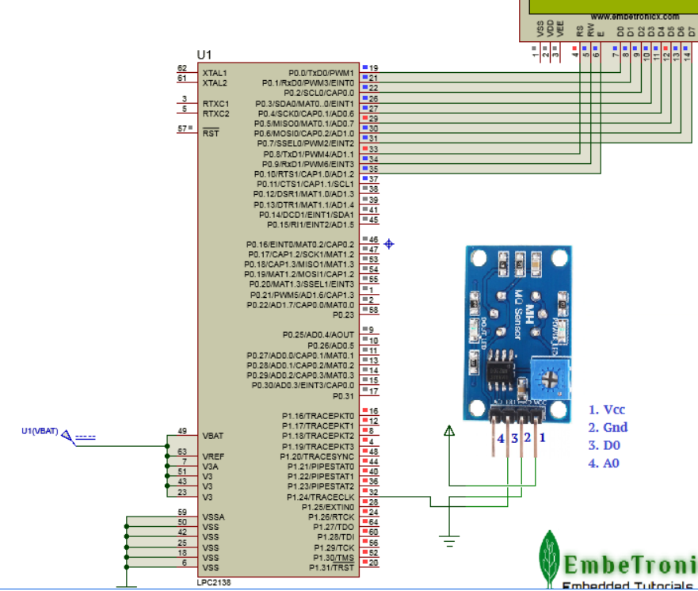

**Applications:**

* Detects or measures Gases like LPG, Alcohol, Propane, Hydrogen, CO, and even methane
* Air quality monitor
* Gas leak alarm
* Safety standard maintenance
* Maintaining environmental standards in hospitals